**mds01_B10308032_呈現圖形**

***導師：林孟彥 (Tom)、林建興(Zino)、鍾皓軒(Howard)***

***學生：B10308032方聖瑋 (LeBron-Willy)***

train = read.csv('MDS實作_#01_資料檔_train2.csv', fileEncoding ="UTF-8")

install.packages('lubridate')

library(lubridate)

train$season <- factor(train$season, labels = c("Spr", "Sum", "Aut", "Win"))

train$weather <- factor(train$weather, labels = c("Sunny", "Cloudy", "Rainy", "Rainy & Cold"))

train$hour <- factor(hour(ymd_hms(train$datetime)))

train$times <- as.POSIXct(strftime(ymd_hms(train$datetime), format="%H:%M:%S"), format="%H:%M:%S")

train$jitter_times <- train$times+minutes(round(runif(nrow(train),min=0,max=59)))

train$Weekday <- lubridate::wday(ymd_hms(train$datetime), label=TRUE)

install.packages('plyr')

library(plyr)

install.packages('reshape2')

library(reshape2)

weather_prob <- ddply(train,.(season, hour),

summarise, Good = mean(weather == "Sunny"),

Normal = mean(weather == "Cloudy"),

Bad = mean(weather == "Rainy"),

Very_bad = mean(weather == "Rainy & Cold"))

ggplot(train, aes(x = hour, y = Good, colour = season)) +

geom_point(data = weather_prob, aes(group = season)) +

geom_line(data = weather_prob, aes(group = season)) +

scale_x_discrete("一天24小時分布") +

scale_y_continuous("出太陽的機率") +

theme_minimal() +

ggtitle("好天氣與單車租借的關係\n(在Aut時，好天氣的機率最高)") +

theme(plot.title=element_text(size=18))

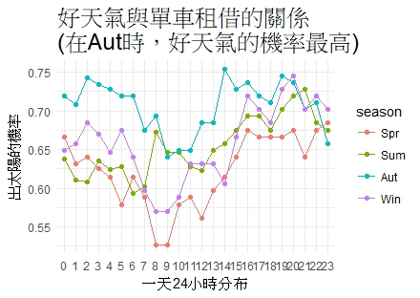

***Sincerely,  
LeBron-Willy***